Metropolitan Baptist Church

2283 North Fair Oaks Avenue

Altadena, California 91001

Rev. Tyrone Skinner, Pastor

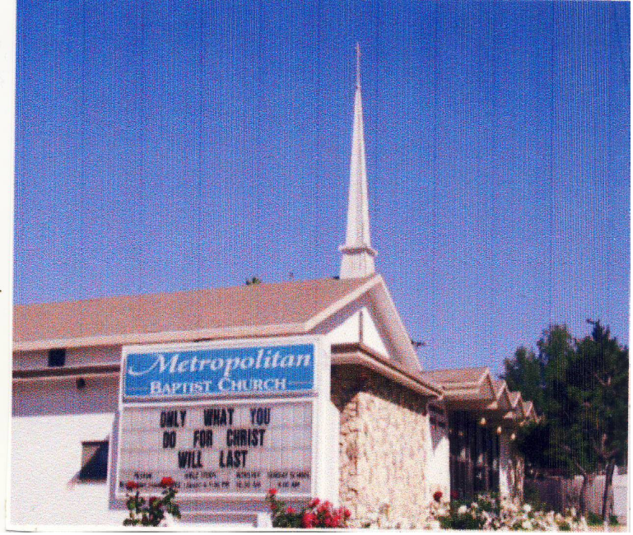

Sunday March 14, 2021

VISION STATEMENT


A lighthouse for Christ in the community

Church Motto: The Church in the Heart of the Community
with the Community at Heart. A place where you can grow.

Church Office (626) 798-8611 E-MAIL: MBCalta@sbcglobal.net

Hall Phone (626) 797-9324 FAX (626) 798-6245

METRO MINISTRY NEWS

For Second Sunday, March 14, 2021

NAACP of Pasadena is offering COVID-19 vaccines on March 27th (2nd Dose) for African-American residents 65 years of age or older. Please contact the NAACP Pasadena Branch Office at (626) 817-9015 to make an appointment.
Submitted by Lady Trudell Skinner
COMMUNITY OUTREACH & EASTER EGG HUNT! We will participate in a Community Outreach for a Food Giveaway and Easter Egg Hunt on the South Lot, Saturday, April 3, 2021 from 2-4 pm.
Submitted by Pastor Skinner

Your Continued Support is Needed: Please continue to send your tithes/contributions to the church by mail to, 2283 North Fair Oaks Ave., Altadena, CA 91001. You may also log onto the church's website which is, mbcaltadena.org and use Pay Pal, or you may drop them off in the church mail slot near the Church Office. Thank you. Stay safe.
Pastor Tyrone Skinner

New Information for Wednesday Noon Bible Study: We are converting from the telephone conference line to Facebook Live and Zoom conferencing for 12 noon Wednesday in the Word. Below you will find the call in information for Zoom in bold and underlined. This is mainly for people who call in. Others can still log on to my personal page on Facebook Live at https://www.facebook.com/tyrone.skinner.9 , or you can do both. Thank you for your patience.
Pastor Ty

Dial by your location
+1 669 900 6833 US (San Jose)
+1 253 215 8782 US (Tacoma)
Meeting ID: 820 2416 1224

Hey everybody.....Moms, Dads, Grandparents: Do you want to set up your posterity to be victorious? Connect with Children's Church on Zoom, Sundays at 11:30 am. Our kids will have fun, while being trained to fight against the devil. They will learn to LOVE God and to LOVE people. Please go to the church's website @ mbcaltadena.org and click on the link to Kingdom Kids. It will take you to our Kingdom Kids gatherings. Thank you
Deaconess Driver, Director of Children’s Ministry

FOR YOU TO KNOW: Kaiser is offering COVID vaccines to members and nonmember (community) based on the current categories directed by the Governor. Call for appointments at 1-833-KP4CARE or KP.org/COVID vaccine.
Kathy Murrell

Just a reminder to the membership to go to the church website, www.mbcaltadena.org and/or Facebook Live at mbcaltadena, to watch worship services on Sundays at 10 am, and to tune into FaceBook Live on Wednesday Noon for Bible study. Also join Pastor Skinner and others on the Prayer Line, (425) 436-6302, ACCESS CODE: 818334 #, Monday thru Friday from 6:00 am-7:00 am.

For You to Know: Due to the COVID-19 PANDEMIC, the Church Office will be opened on abbreviated hours Monday thru Friday, and closing at 3:30 pm until further notice. Please call the Church Office to verify opening hours.

COMMUNITY INFORMATION!



** F R E E **

COVID-19 TESTING

FEBRUARY 23, 2021 to JUNE 30, 2021

TUESDAYS: 10am-5pm WEDNESDAYS: 1pm-8pm
THURSDAYS: 10am-5pm

REQUIREMENTS:
DRIVE -UP ONLY
WEAR A MASK
FOLLOW THE DIRECTIONS OF THE STAFF

LOCATION: First AME Church of Pasadena 1700 North Raymond Ave
Pasadena, CA 91103 // 626-798-0503
Registration Required / Se Requiere RegistroRegister at / Registrese
en:http://bit.ly/aacec-famepasadena



